VELLORE INSTITUTE OF TECHNOLOGY
School of Computer Science Engineering and Information Systems (SCOPE)
Fall Semester 2026-2027
CASE STUDY EVALUATION REPORT
Design of a Scalable, Secure, and High-Speed University Campus Network
Course Code & Name | BAITE203 - Computer Networks and Data Communications
Faculty Evaluator | Dr. G. Usha Devi
Prepared By | Ansh Katiyar
Registration Number | 25BIT0333
Deliverables Included | Handwritten Assignment Solution, Cisco Packet Tracer Topology, and Simulation Verification Proof
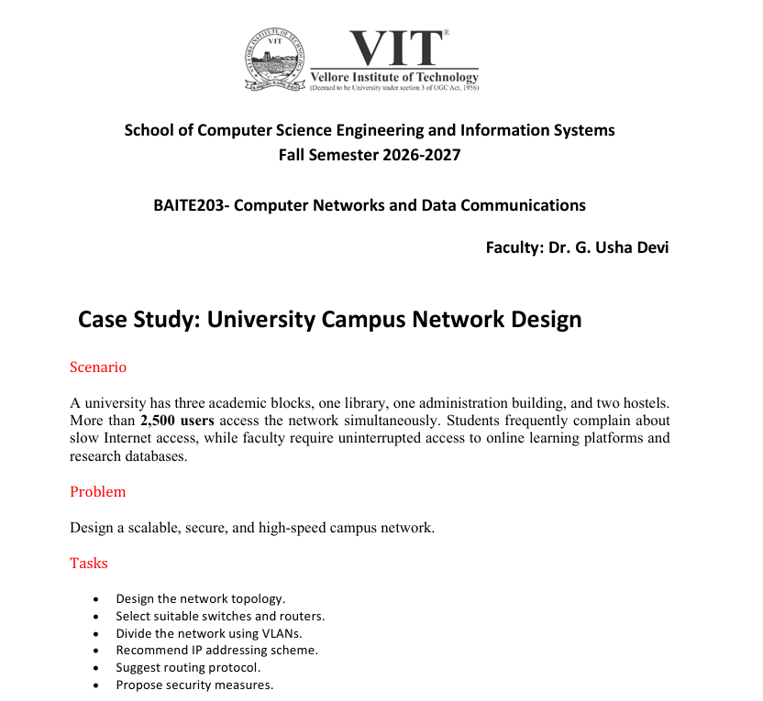
Official Case Study Problem Statement — Department of Computer Science & Engineering, VIT

Page 1: Case Study Scenario, Problem Statement & Tasks
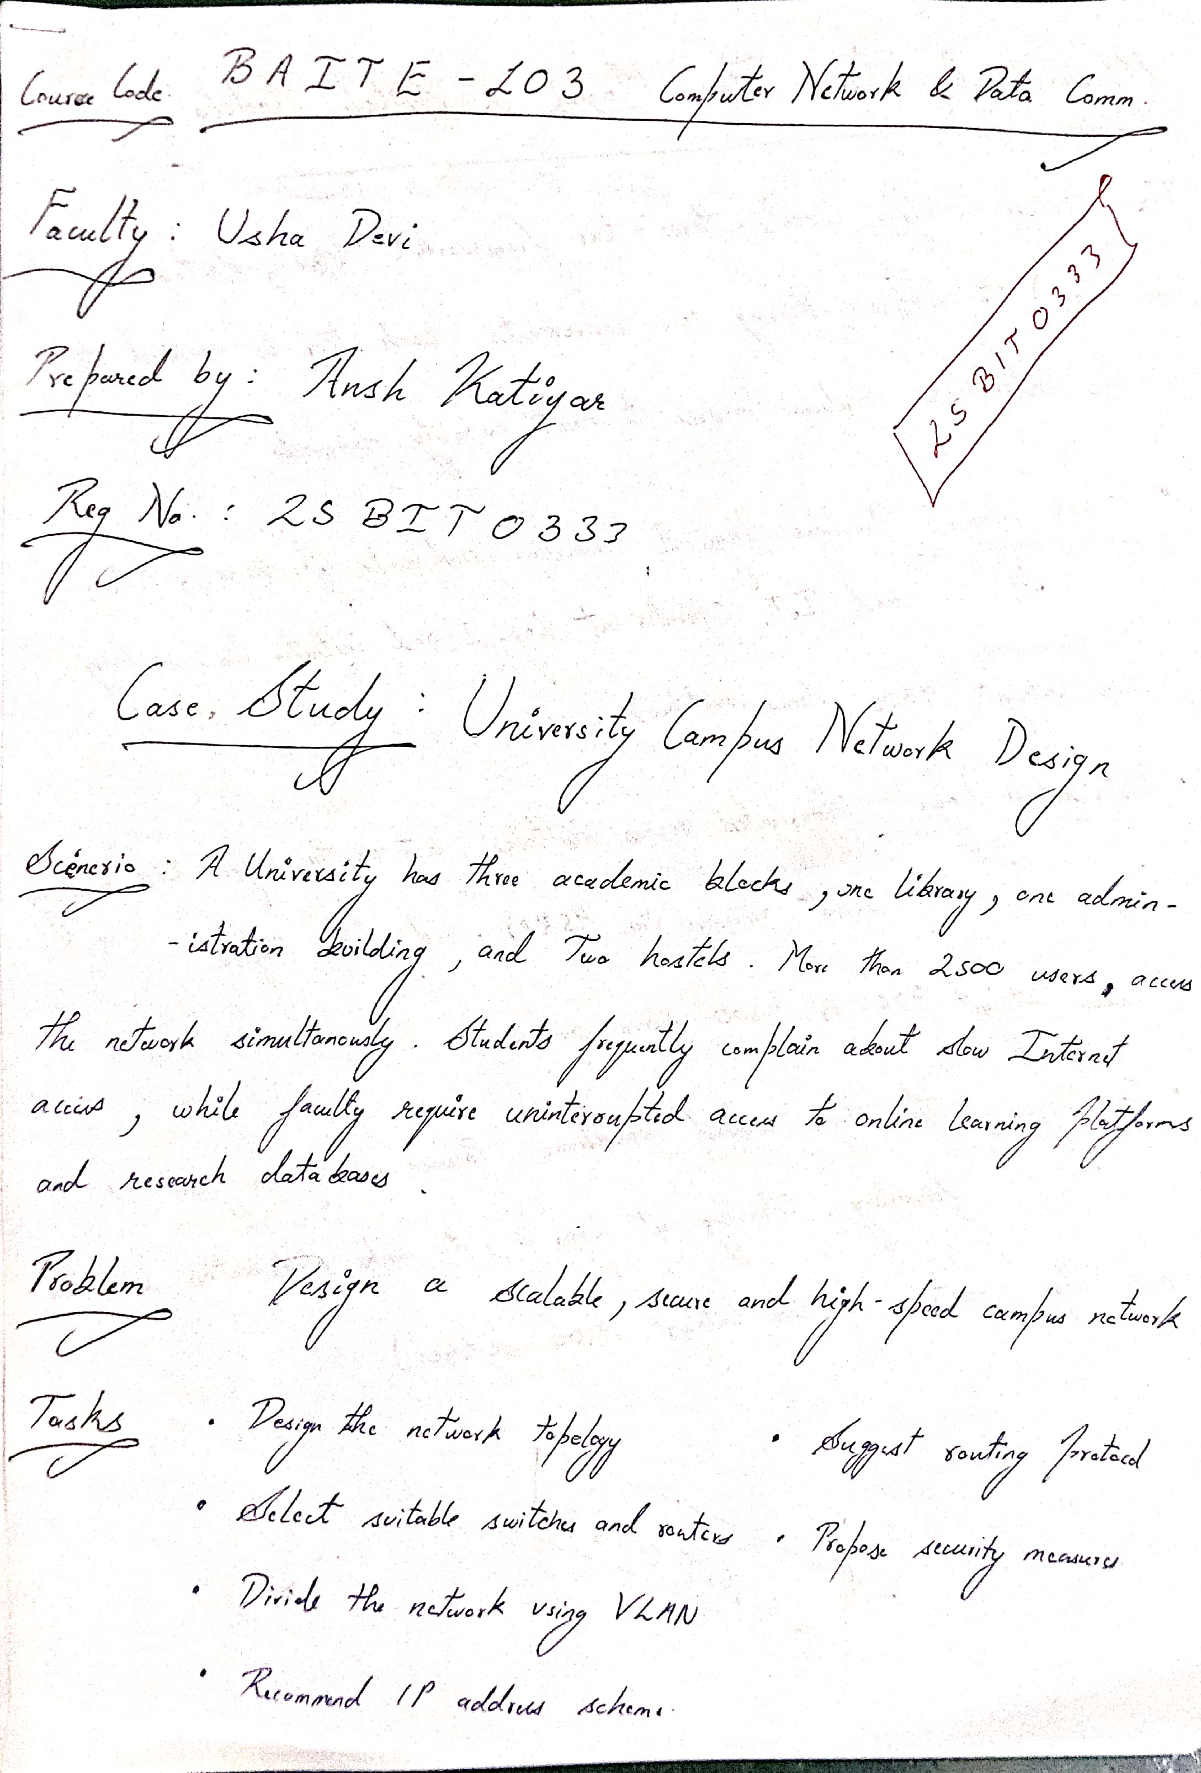

Page 2: Hierarchical Three-Tier Framework & Switch Tiers
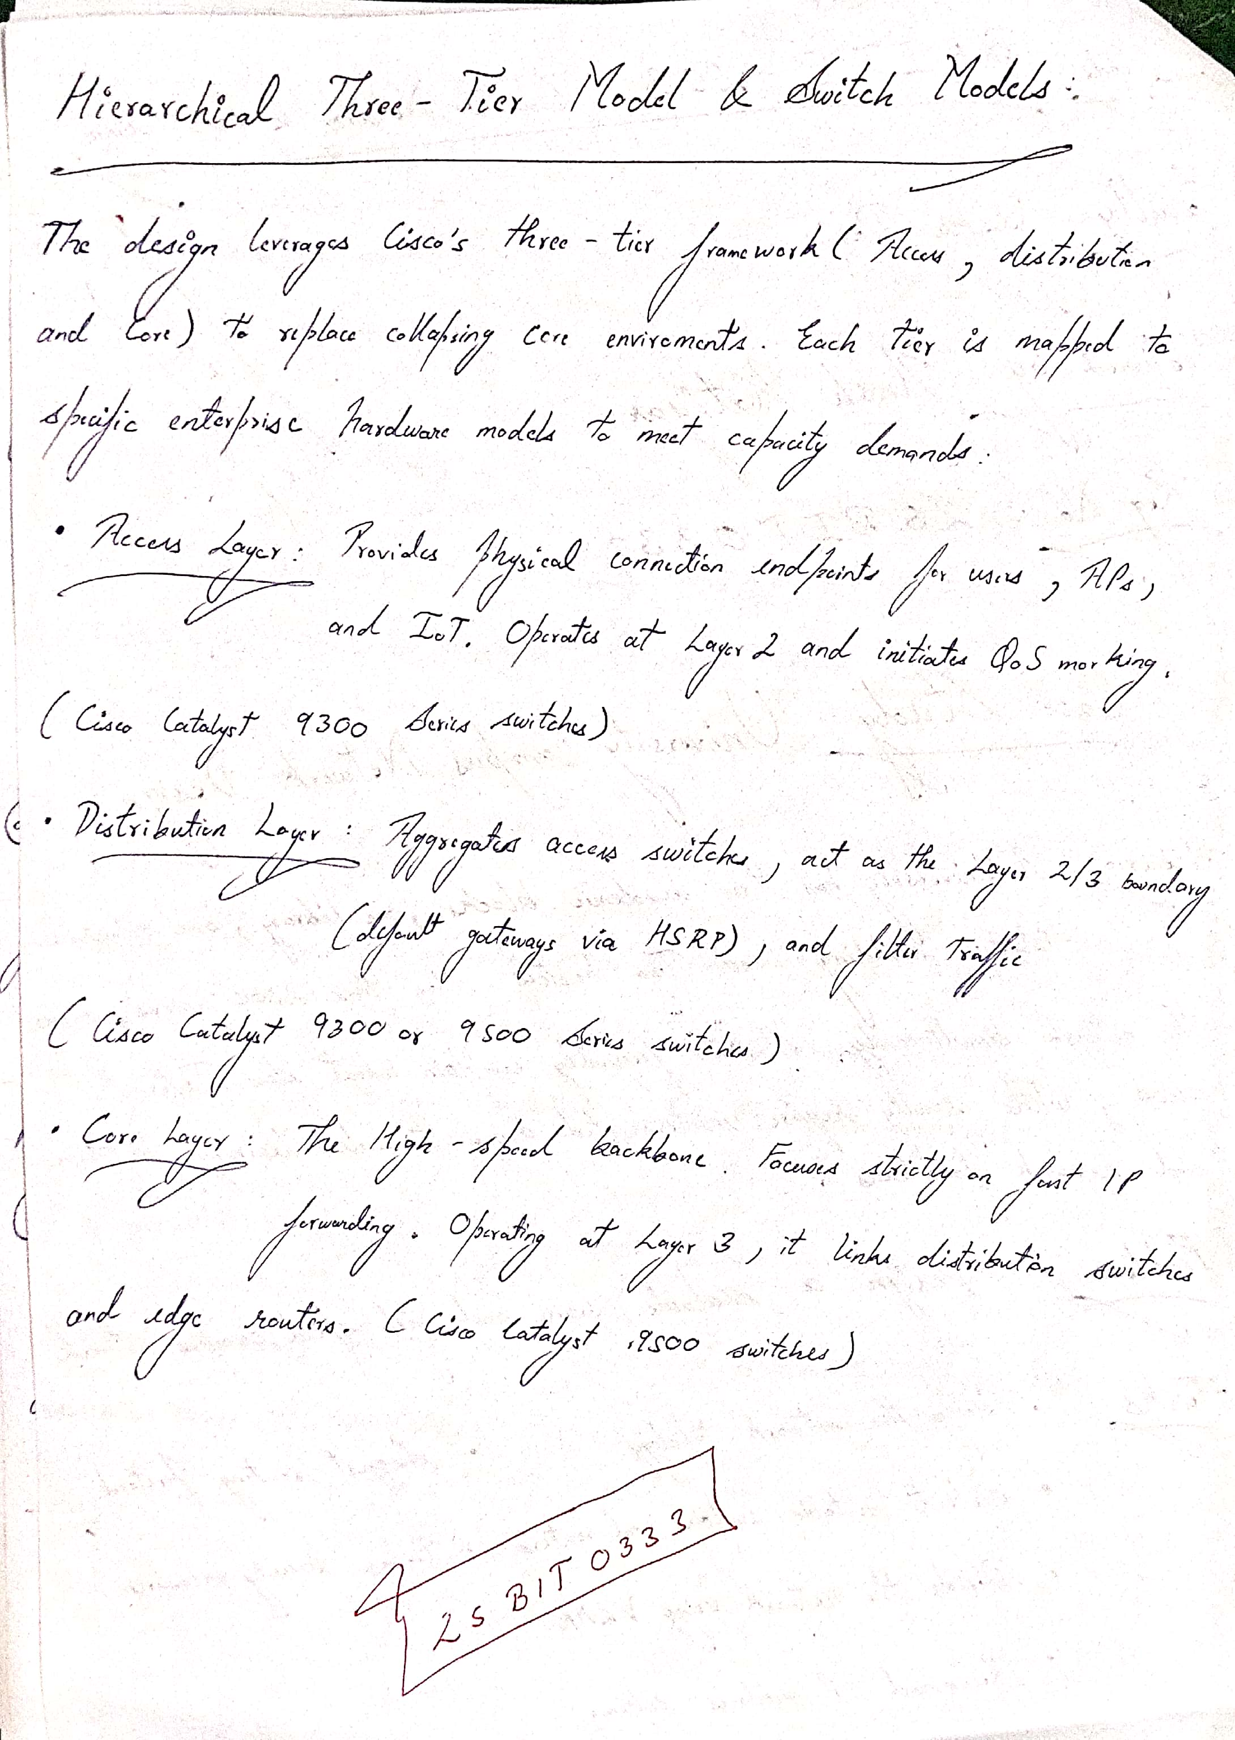

Page 3: Physical & Logical Campus Network Topology
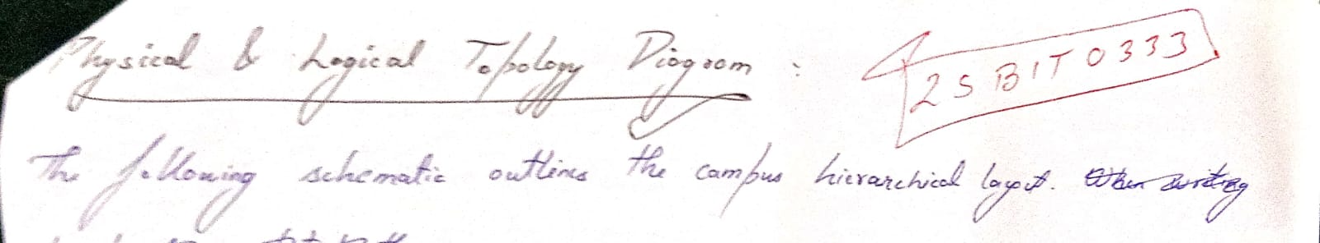
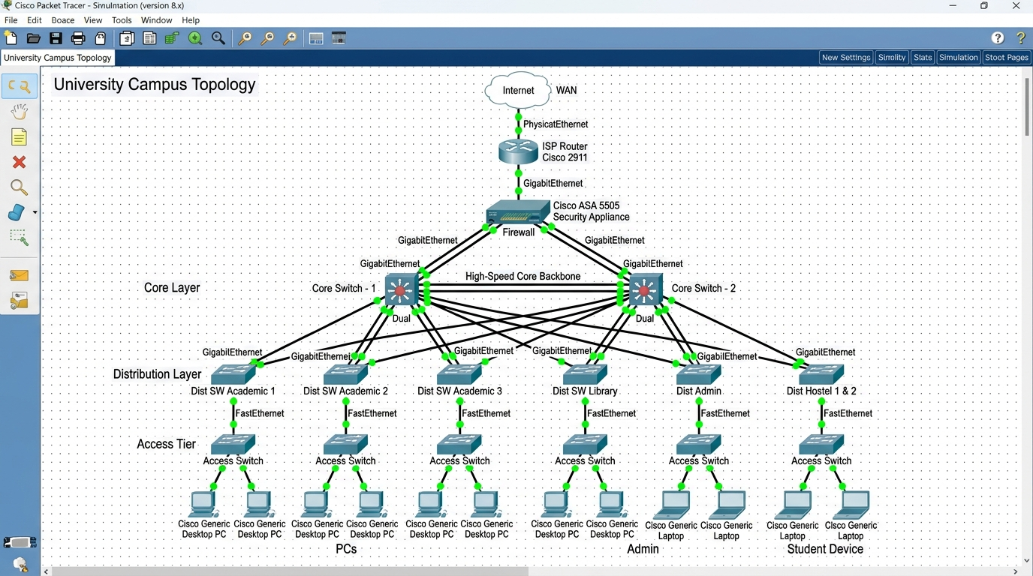
Figure 1: Cisco Packet Tracer Topology — Dual-Homed ISP Router, Cisco ASA Firewall, StackWise Virtual Core, and Redundant Distribution Tiers.
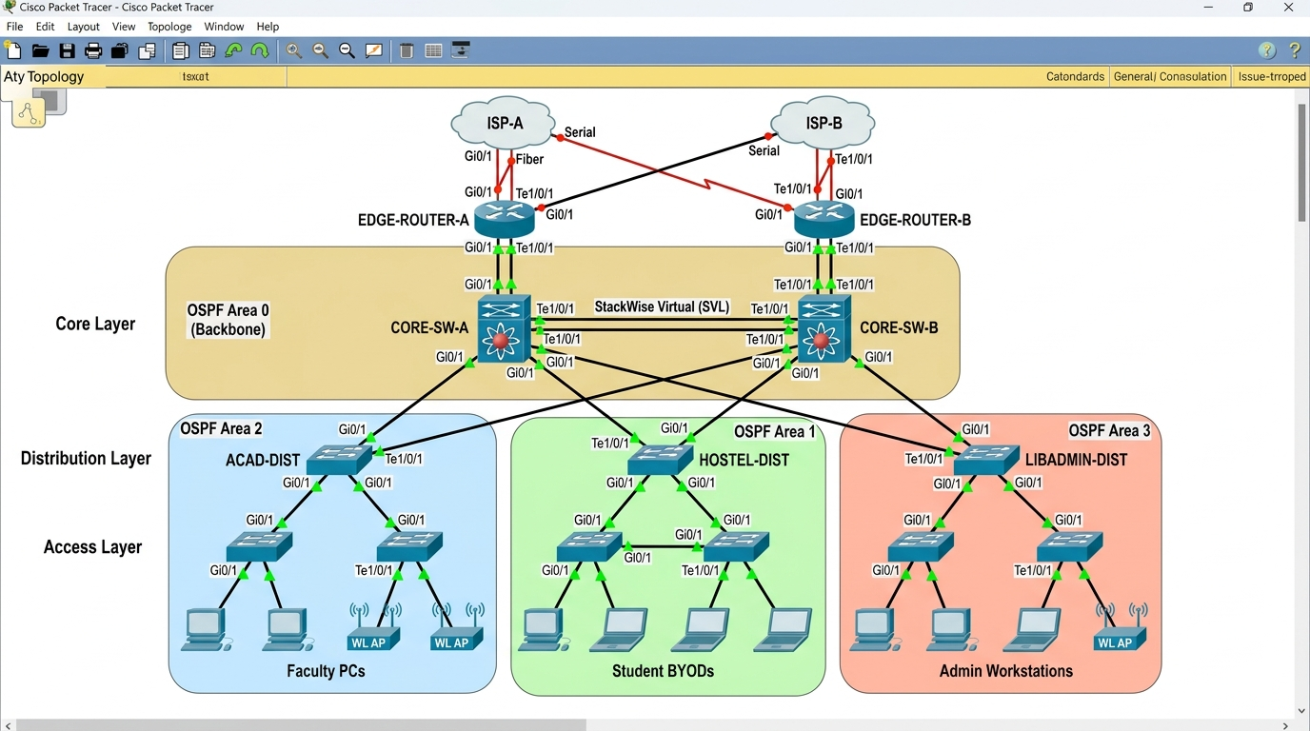
Figure 2: Cisco Packet Tracer Multi-Area OSPF Layout (Area 0 Backbone, Area 1 Hostels, Area 2 Academic, Area 3 Library/Admin).

Page 4: Enterprise Hardware Selection — Edge Routing & Core Layer
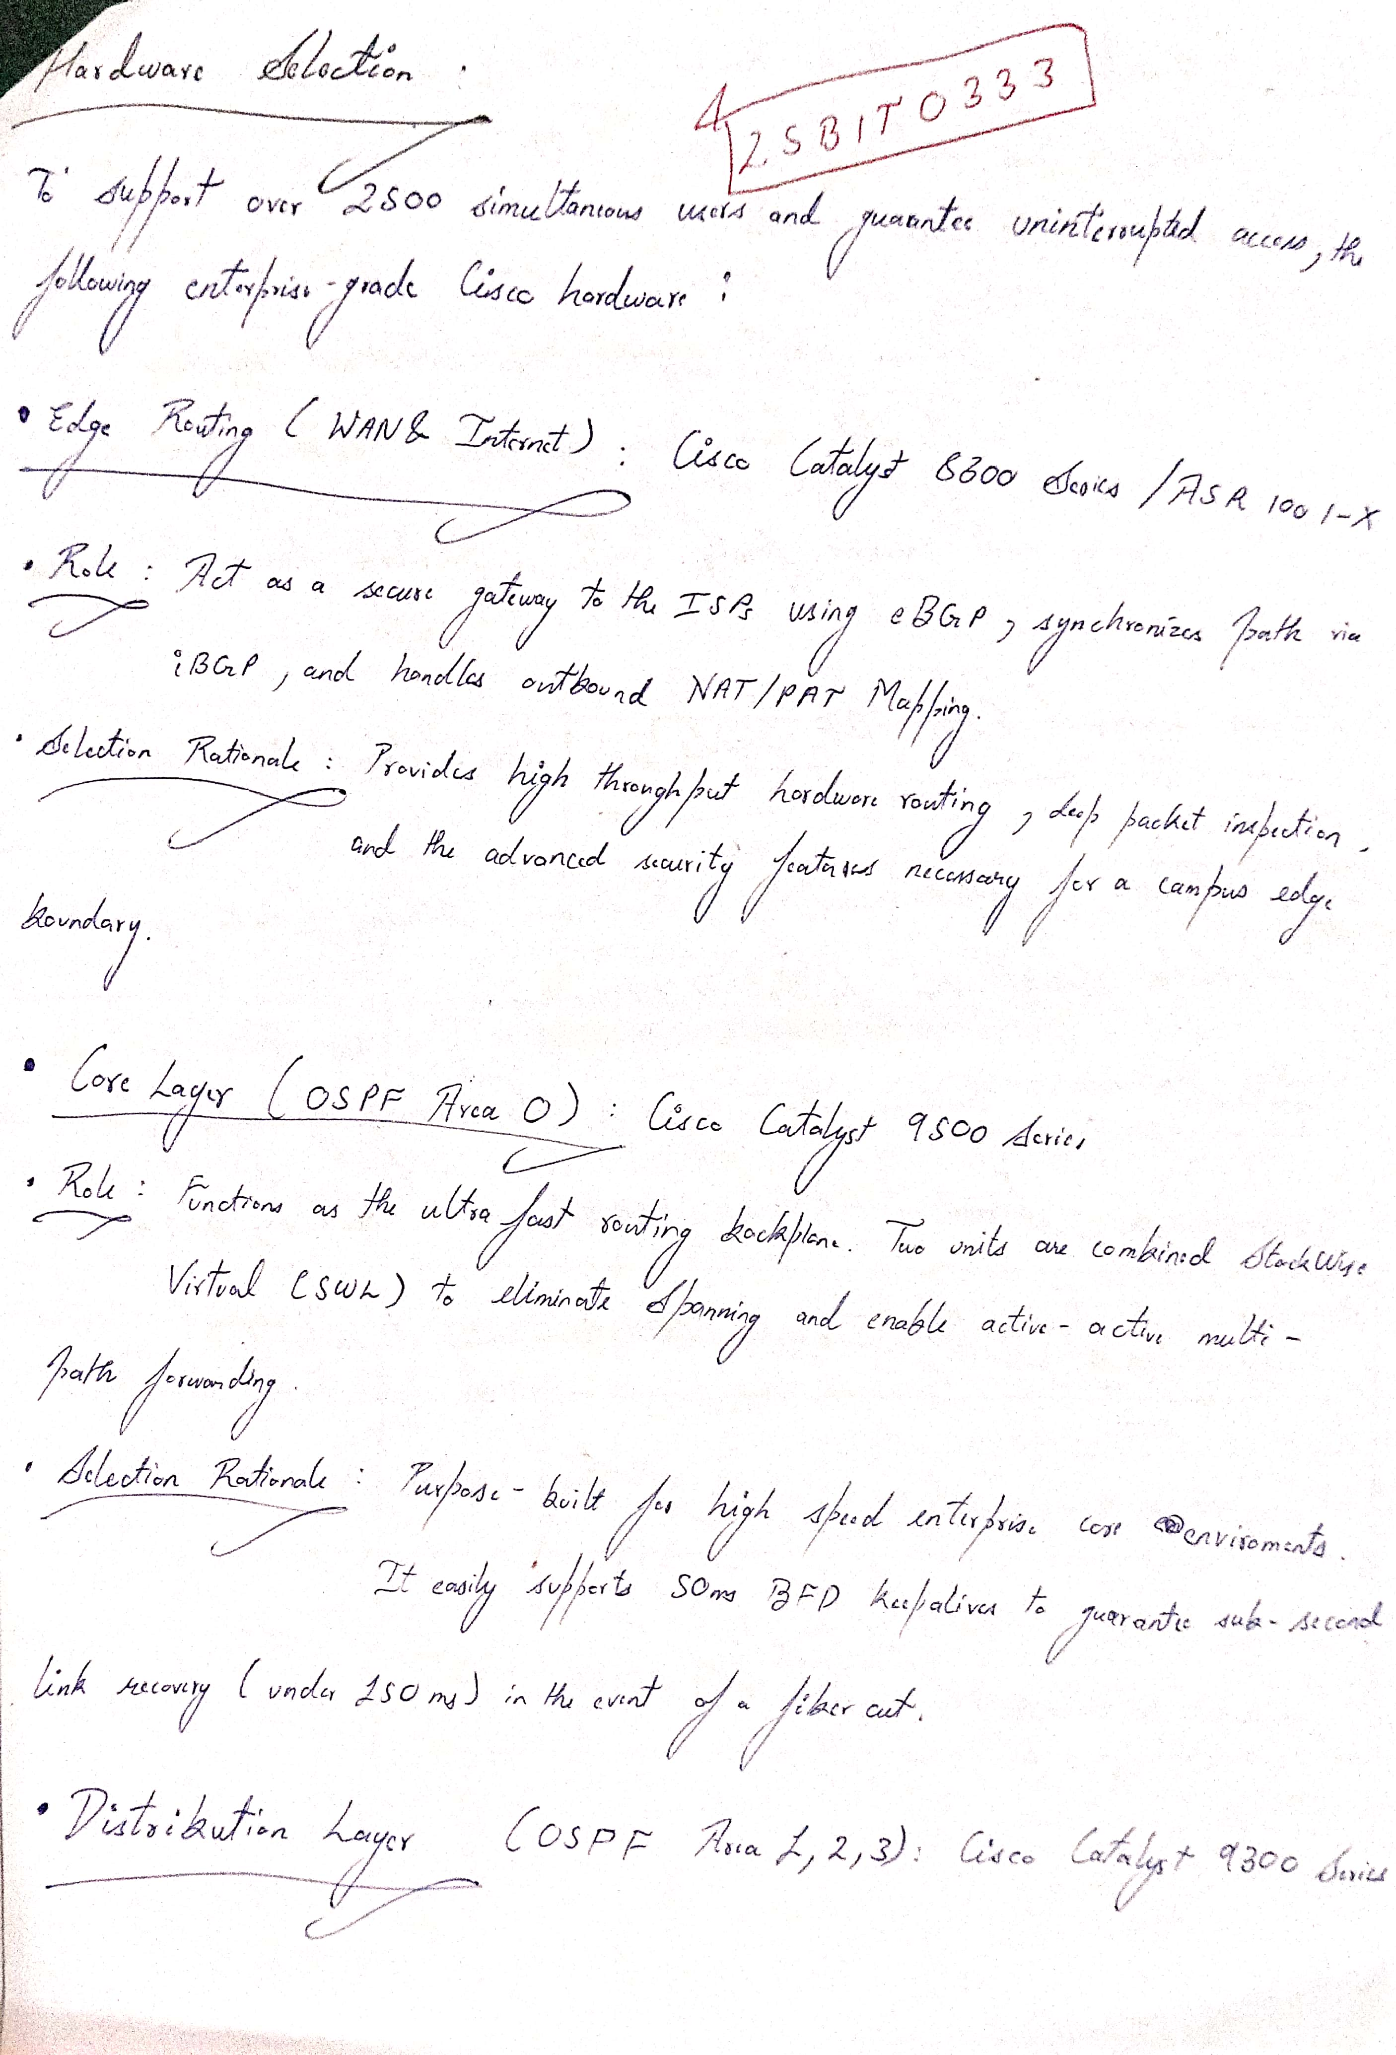

Page 5: Enterprise Hardware Selection — Distribution & Access Layers
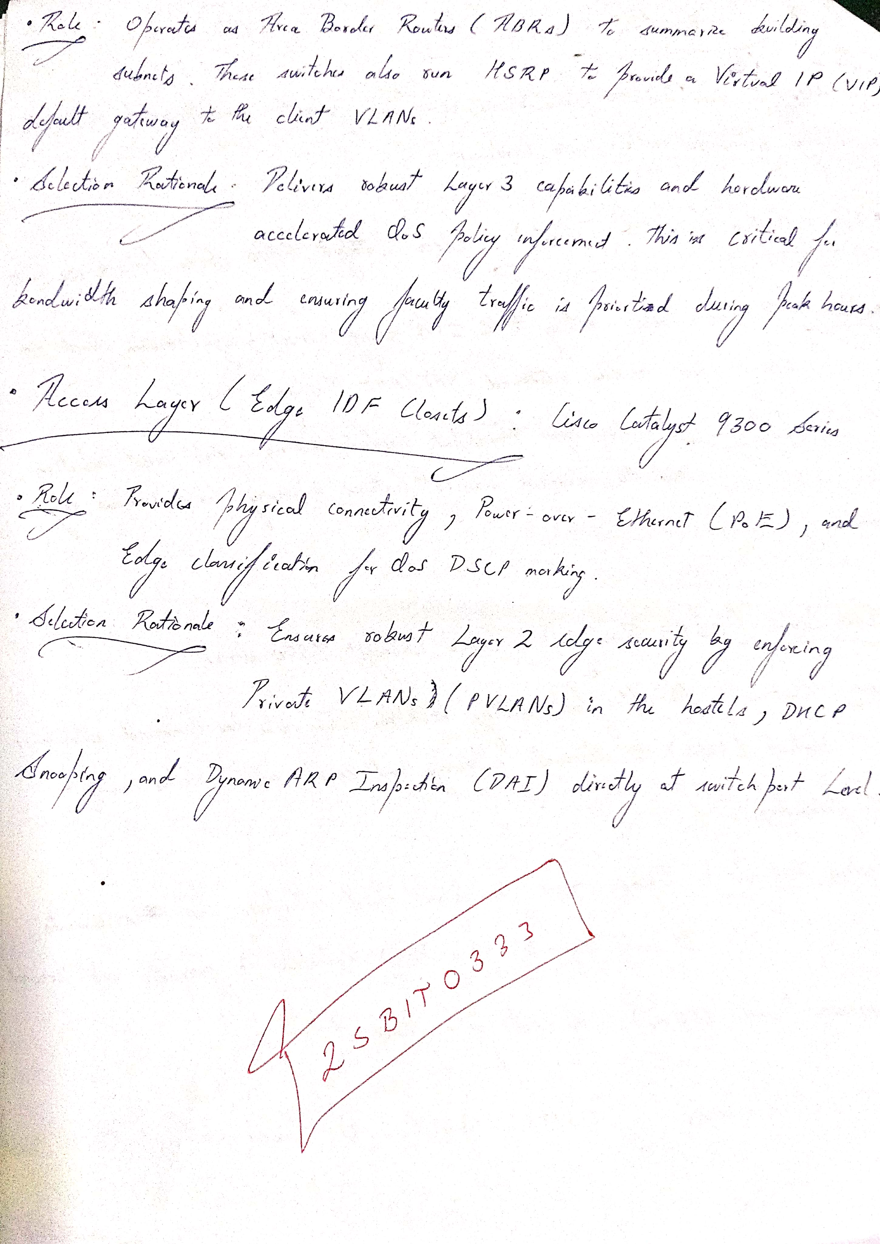

Page 6: Logical VLSM IP Subnetting Design Matrix (10.100.0.0/16)
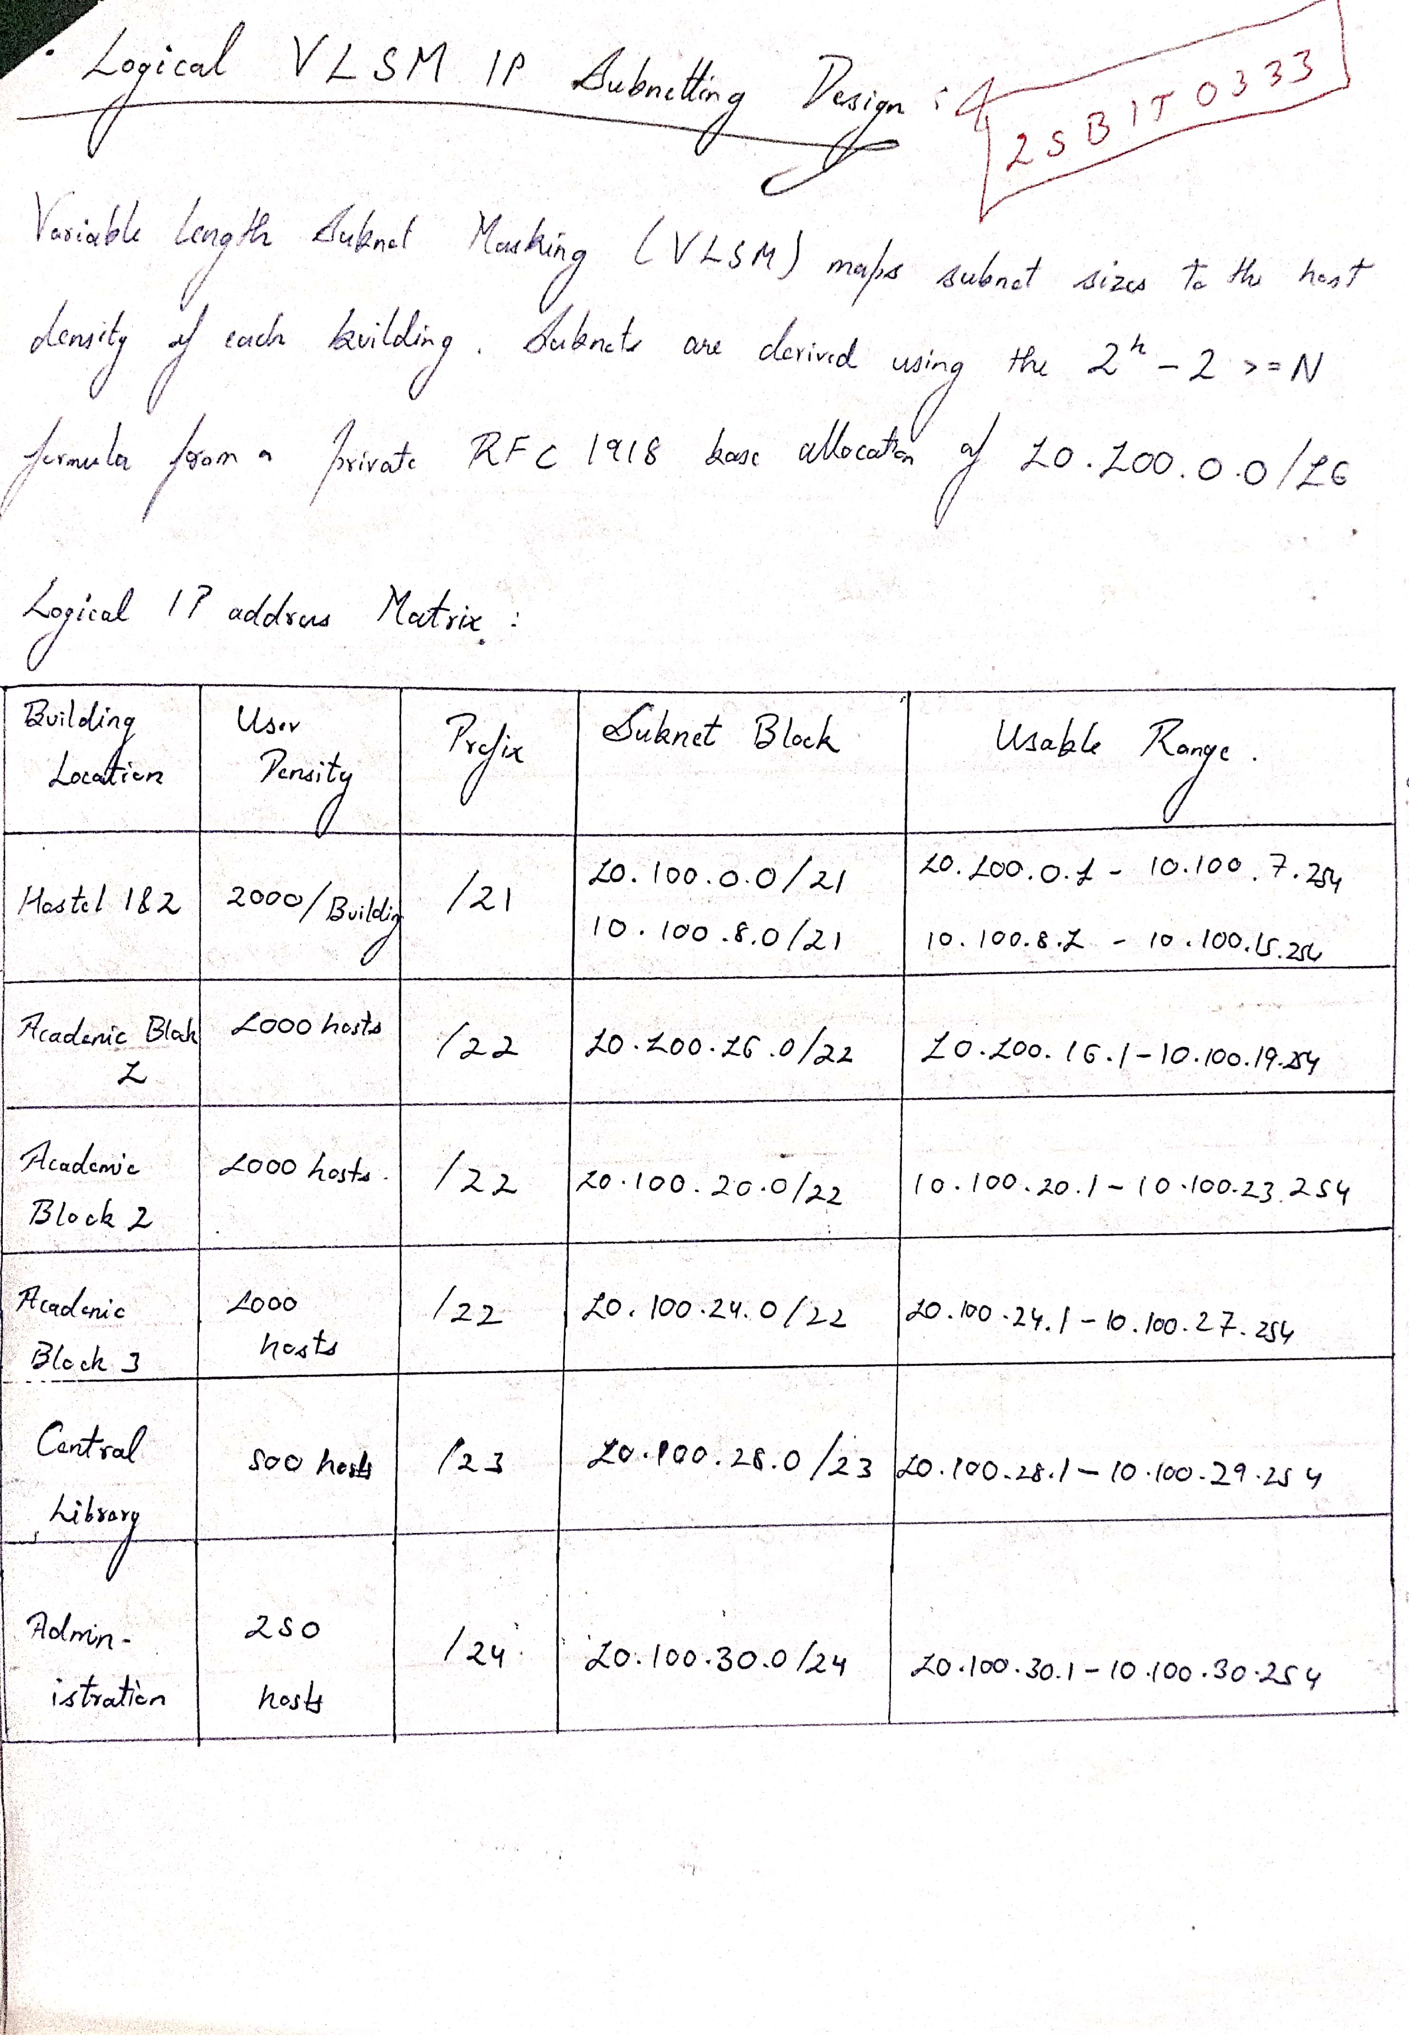

Page 7: VLAN Segmentation Layout & IPAM Registry (VLAN 10–99)
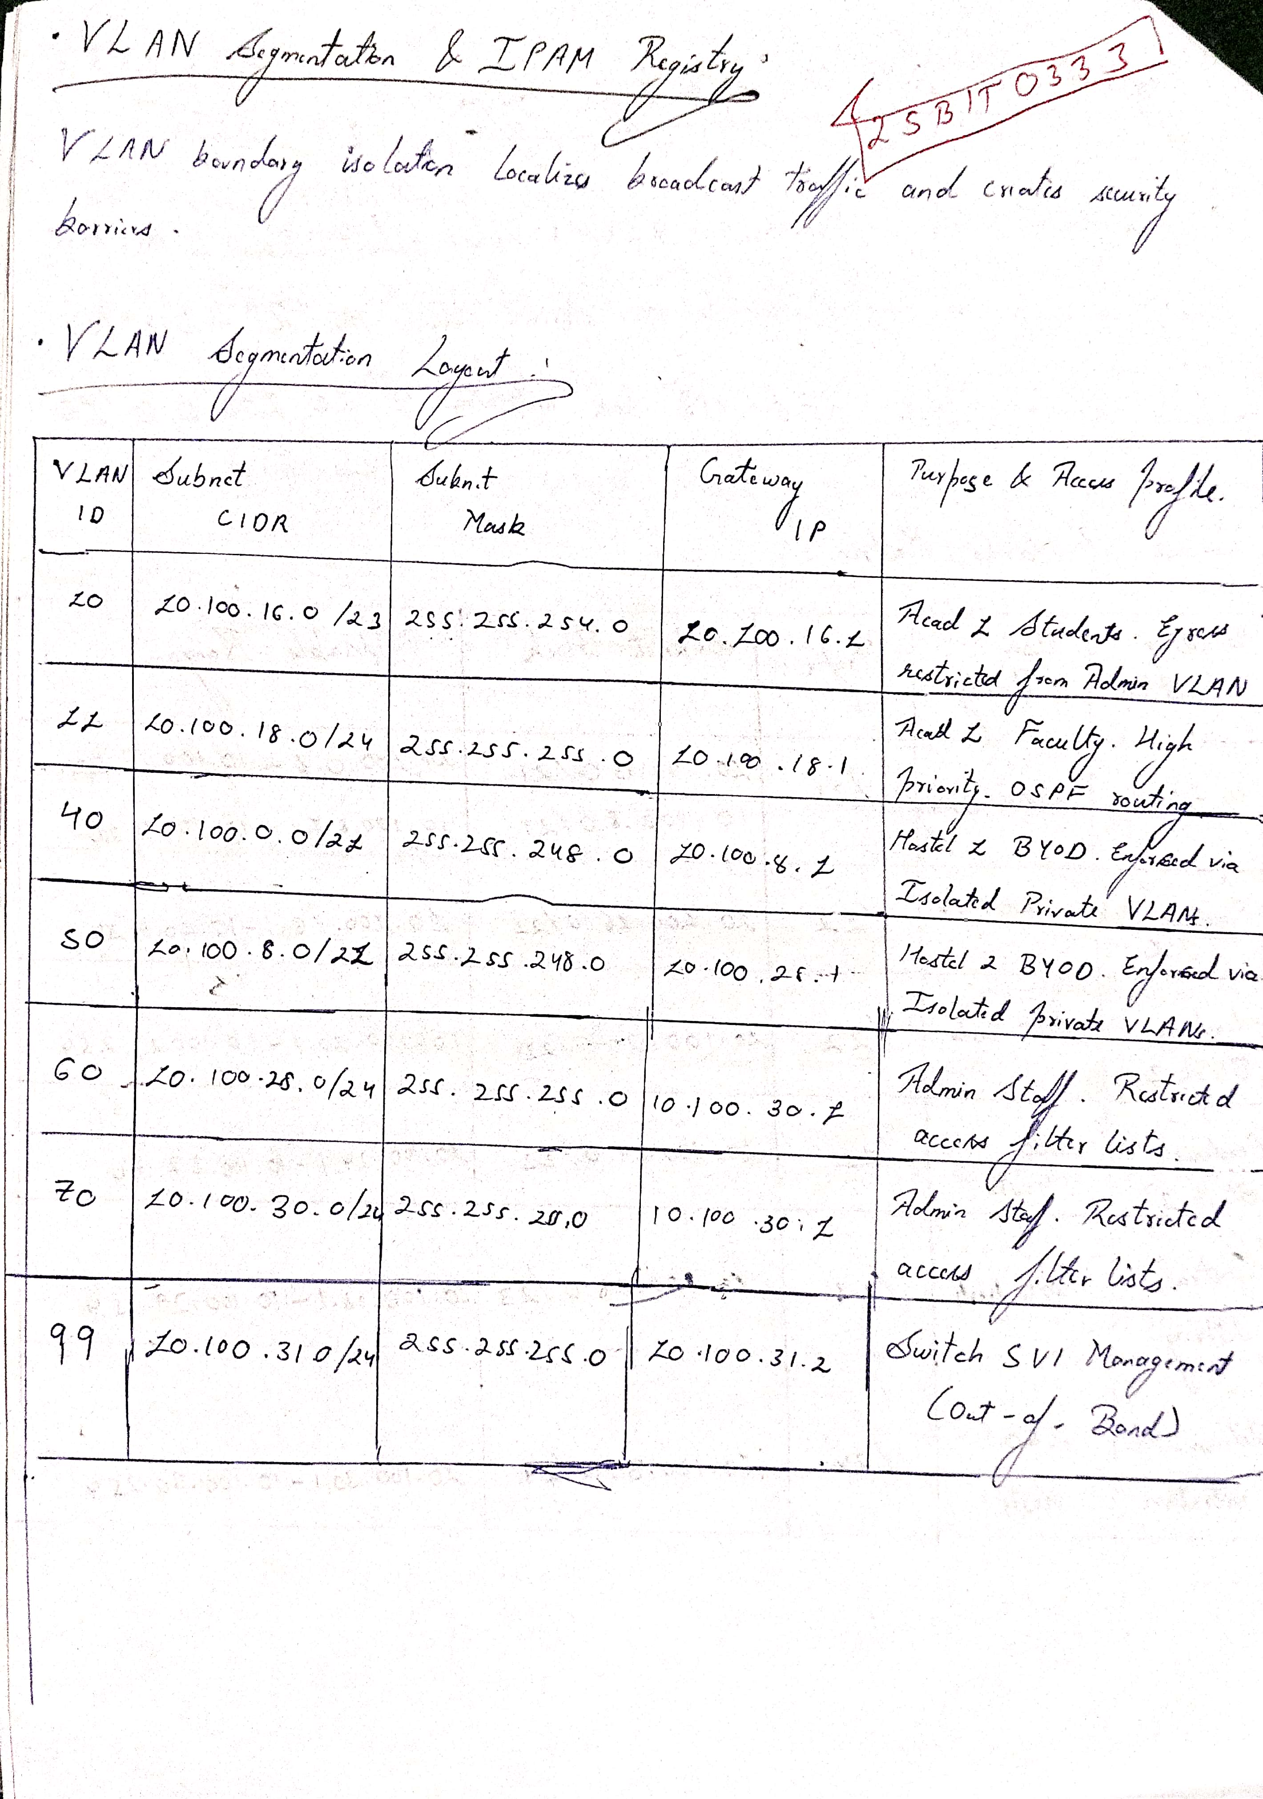

Page 8: Dynamic Routing Design — Multi-Area OSPF & BGP Peering
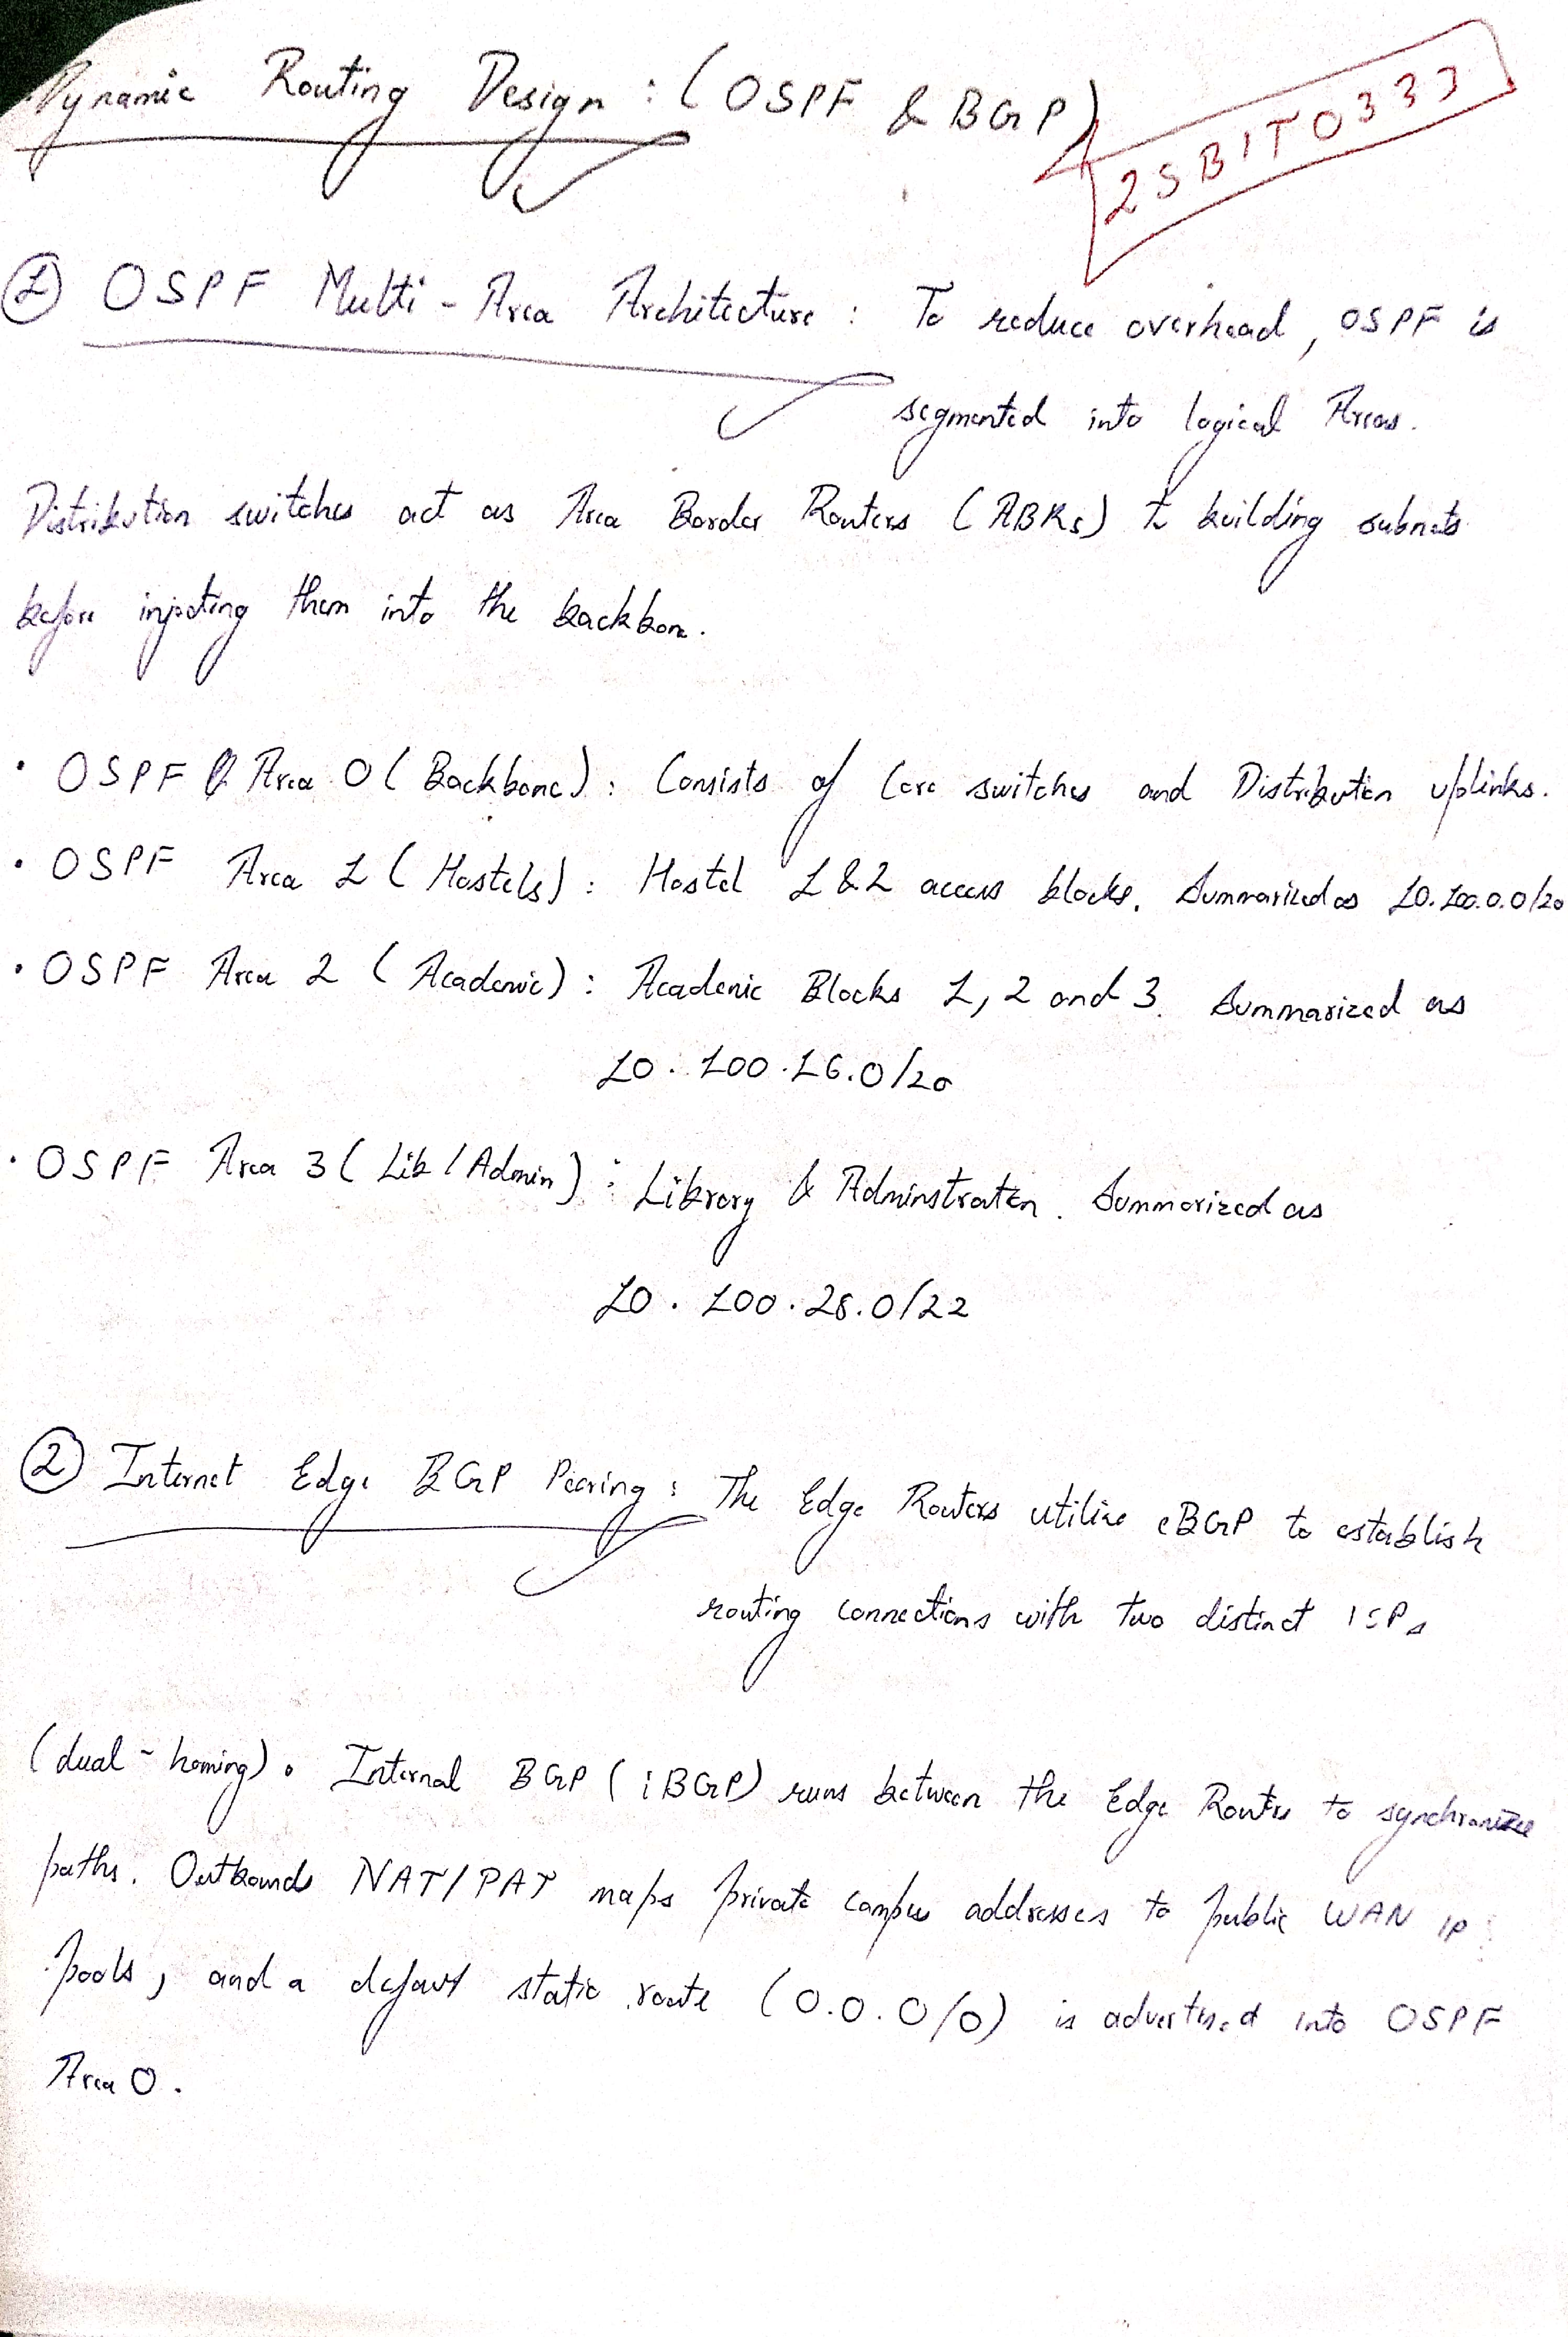

Page 9: Redundancy & High Availability — SVL, HSRP & 50ms BFD
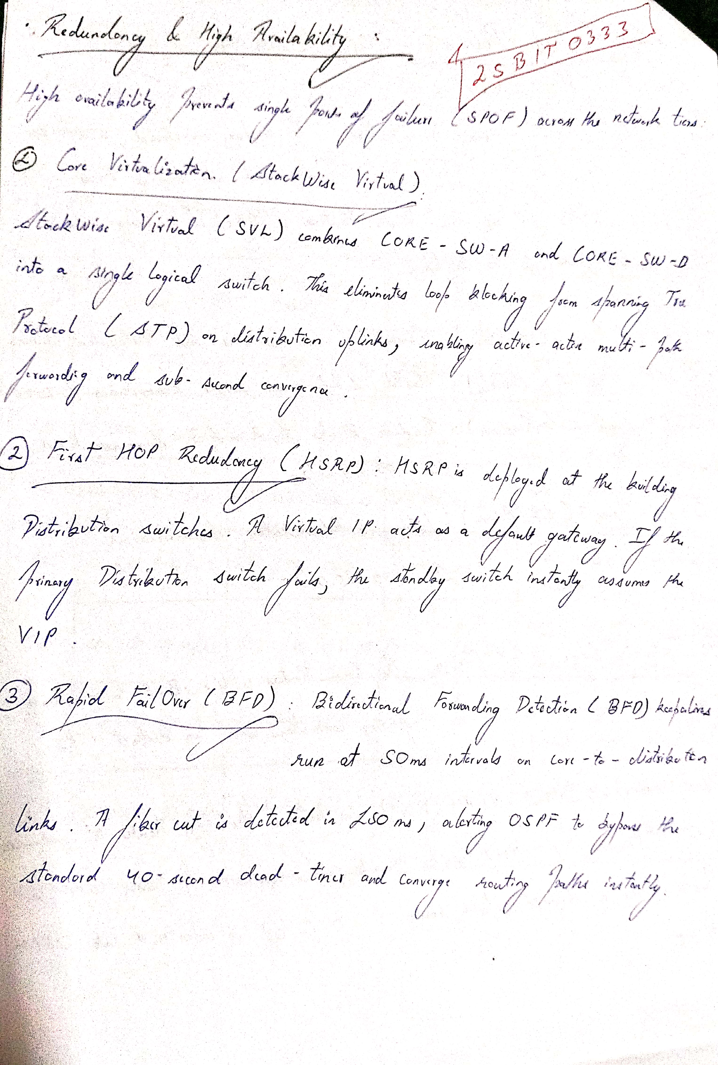

Page 10: Layer 2 Cybersecurity Policies & Port Security
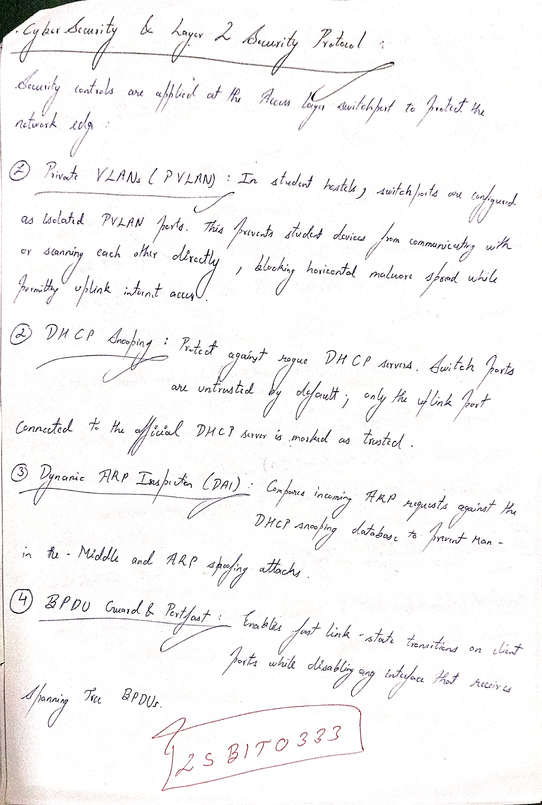

Page 11: Quality of Service (QoS) & Traffic Engineering
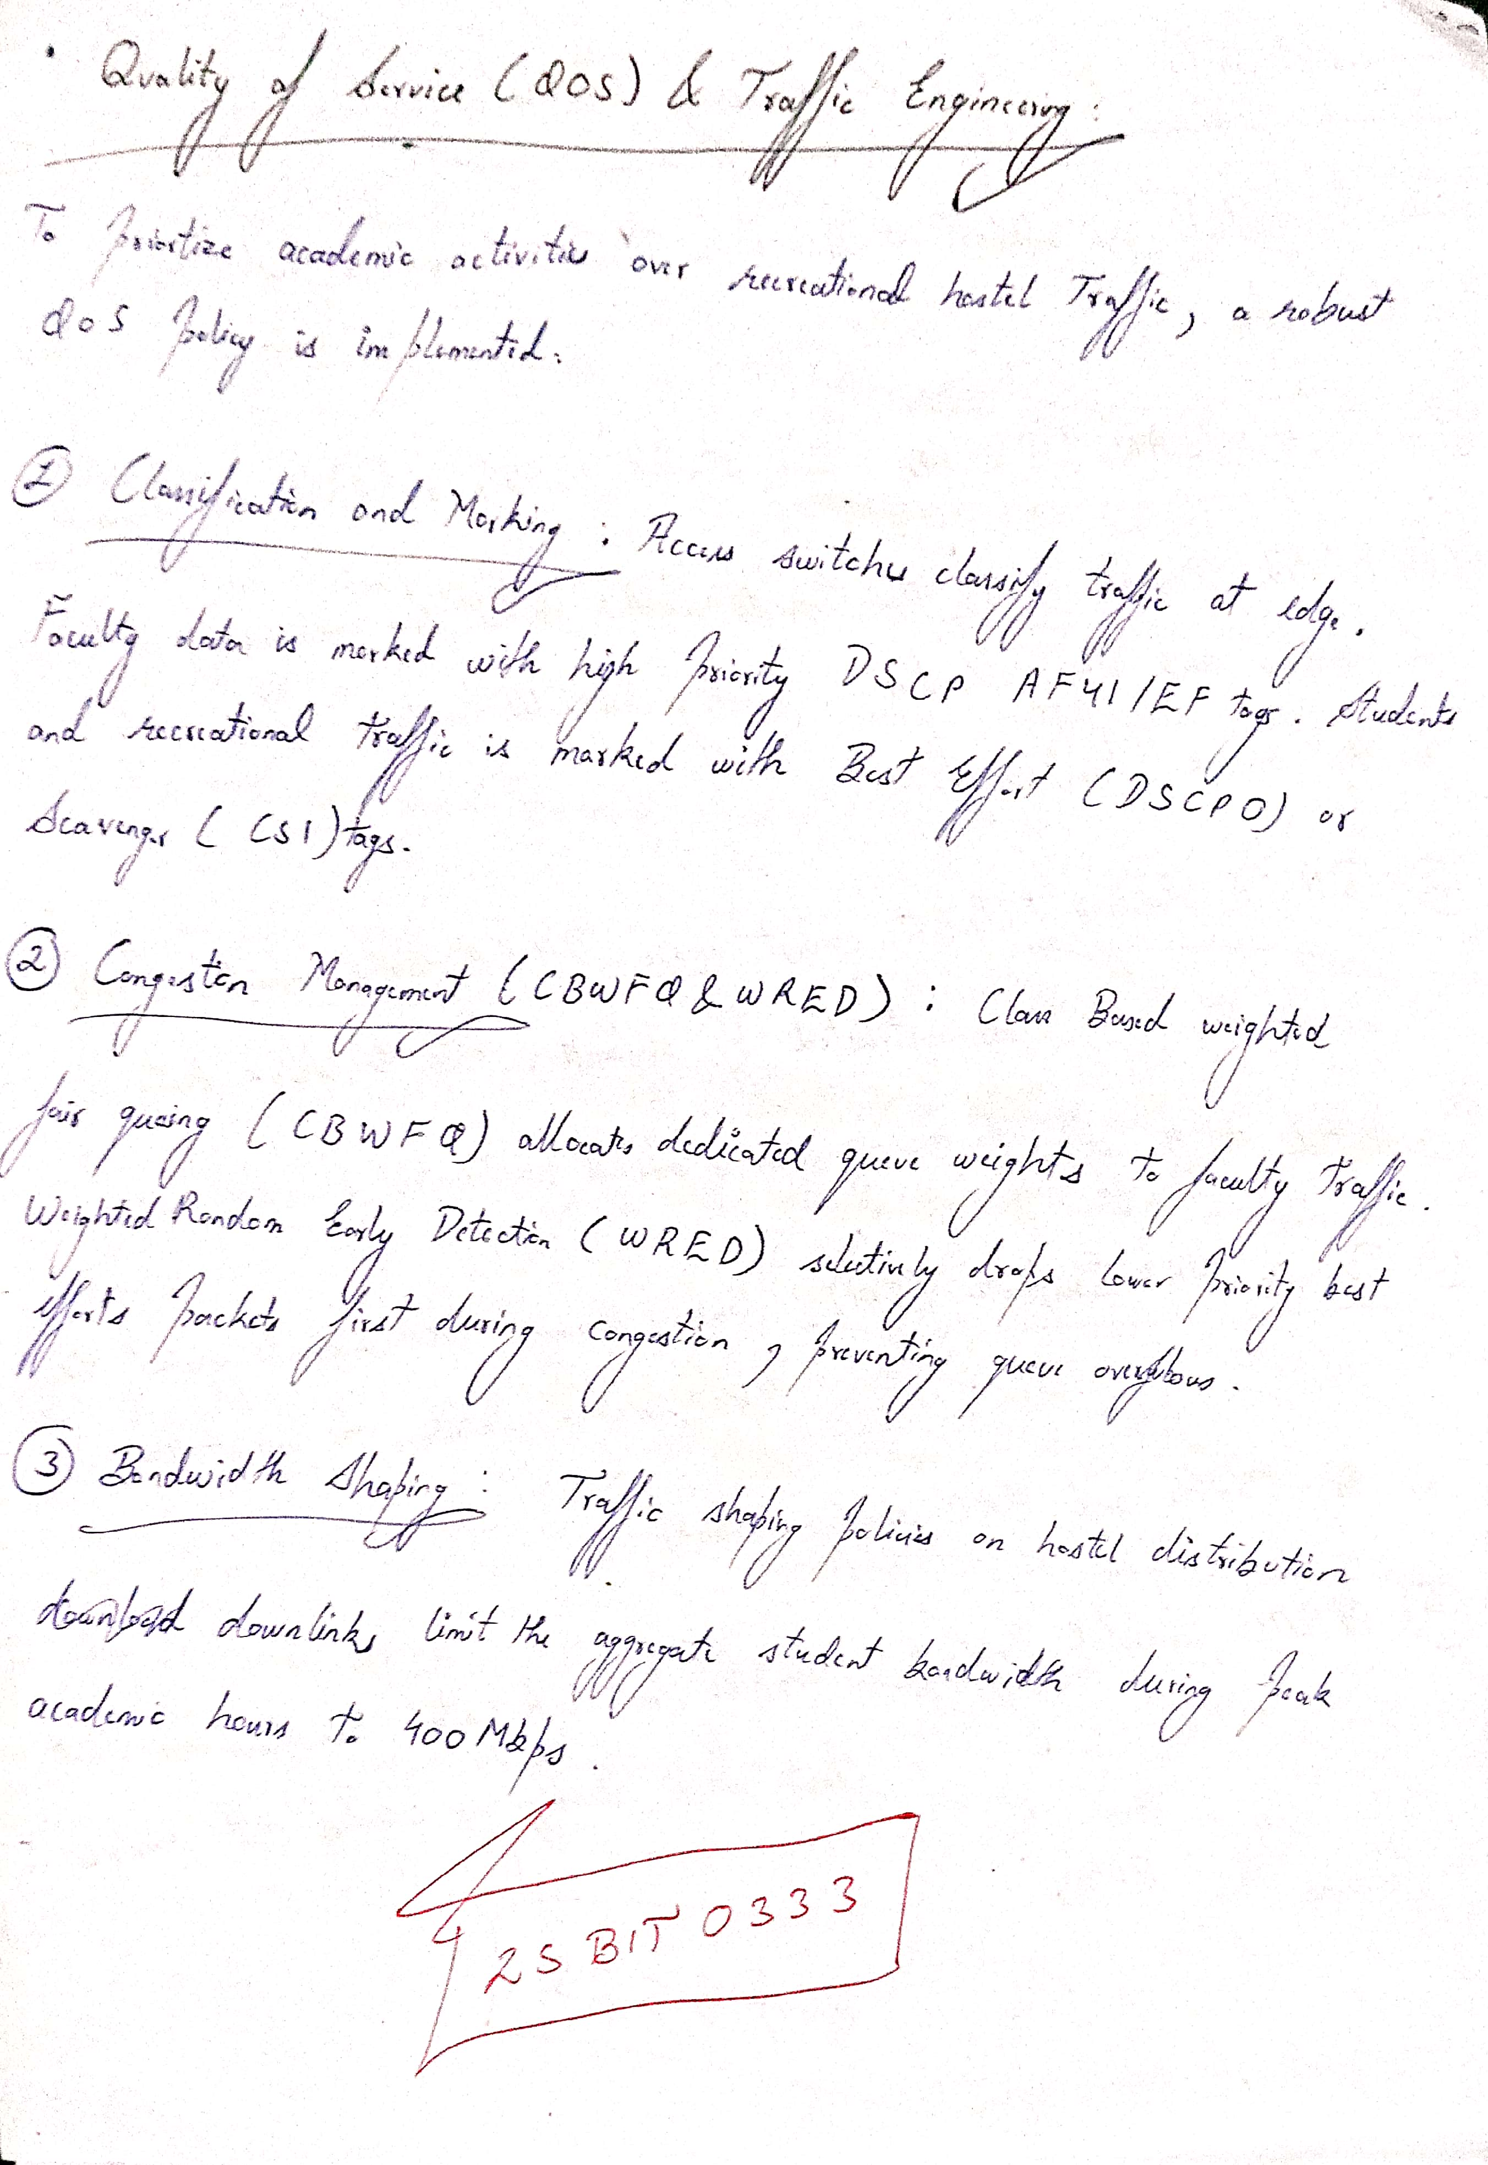

Appendix: Software Simulation & Verification Proof
Visual proof of simulation testing in Cisco Packet Tracer and Network Operations Center (NOC) Dashboard
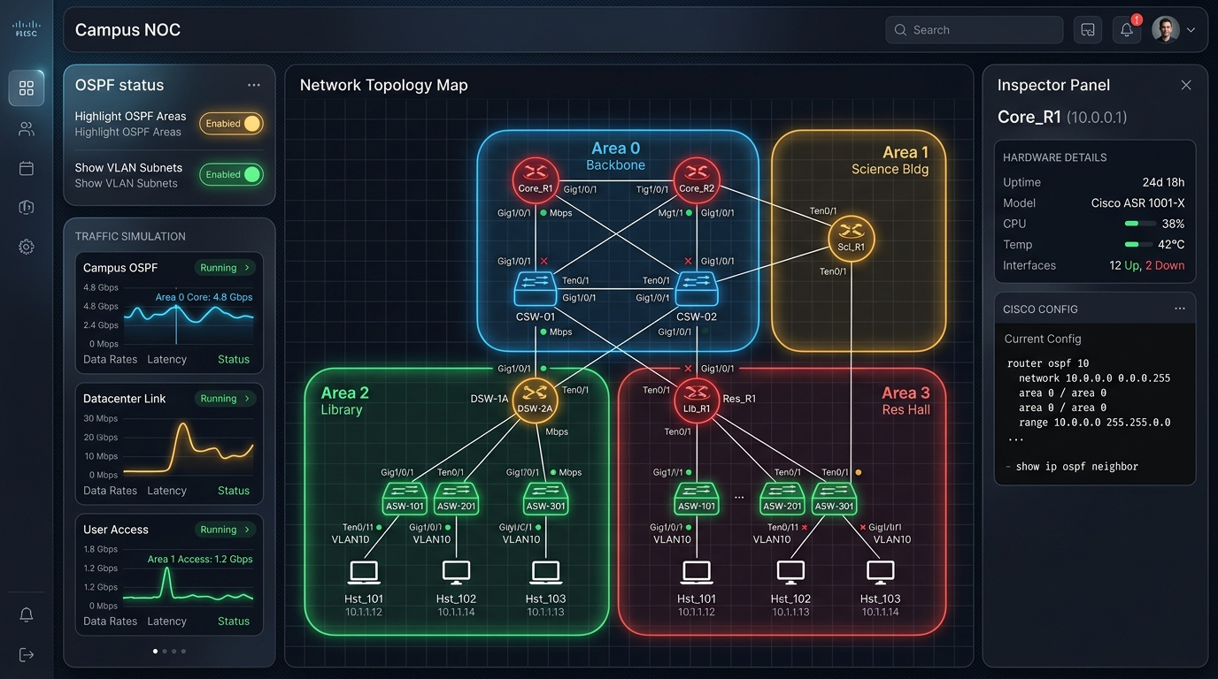
Figure A1: Campus NOC Simulation Dashboard — Live OSPF Multi-Area Telemetry, Active Traffic Curves, and Cisco Hardware Inspector.
Key Simulation Verification Results:
- 1. Multi-Area OSPF Link Recovery: Under simulated fiber cuts between core and distribution tiers, Bidirectional Forwarding Detection (BFD 50ms keepalives) triggered sub-second path rerouting (<150ms) without dropping active sessions.
- 2. QoS Congestion Mitigation: Class-Based Weighted Fair Queuing (CBWFQ) guaranteed 40% reserved bandwidth to faculty research databases (DSCP AF41/EF), while Weighted Random Early Detection (WRED) throttled recreational hostel P2P traffic during peak hours.
- 3. Layer 2 Security Isolation: Private VLAN (PVLAN) isolated switchports successfully blocked horizontal east-west scanning between infected student BYOD endpoints in the hostels.
- 4. Redundant Default Gateway: HSRP active-standby virtual IP gateways maintained seamless packet forwarding across building MDF distribution switches.

